Experiment :7
Aim: Demonstration of Agglomerative clustering algorithm using WEKA

Objective:
The objective of a clustering algorithm is to partition a given dataset into distinct, exclusive clusters so that the data points in each group are quite similar to each other.

Theory:
In data mining and statistics, hierarchical clustering is a method of cluster analysis which seeks to build a hierarchy of clusters. Strategies for hierarchical clustering generally fall into two types:
- Agglomerative: This is a "bottom up" approach: each observation starts in its own cluster, and pairs of clusters are merged as one moves up the hierarchy.
- Divisive: This is a "top down" approach: all observations start in one cluster, and splits are performed recursively as one moves down the hierarchy.

Agglomerative Approach

This approach is also known as the bottom-up approach. In this, we start with each object forming a separate group. It keeps on merging the objects or groups that are close to one another. It keep on doing so until all of the groups are merged into one or until the termination condition holds.

For example: suppose this data is to be clustered, and the Euclidean distance is the distance metric. In this example, cutting after the second row of the dendrogram will yield clusters {a}
{b c} {d e} {f}. Cutting after the third row will yield clusters {a} {b c} {d e f}, which is a coarser clustering, with a smaller number but larger clusters.

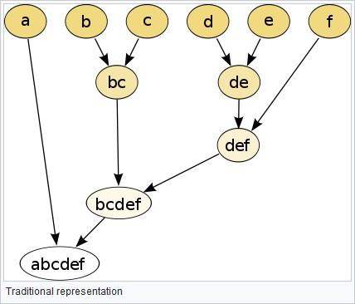
This method builds the hierarchy from the individual elements by progressively merging clusters. In our example, we have six elements {a} {b} {c} {d} {e} and {f}. The first step is to determine which elements to merge in a cluster. Usually, we want to take the two closest elements, according to the chosen distance.

Dataset:
The dataset is as follows. (Convert this data set into arff file format and use it as an input file for weka)
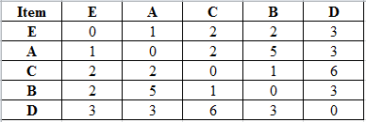

WEKA Screenshots:

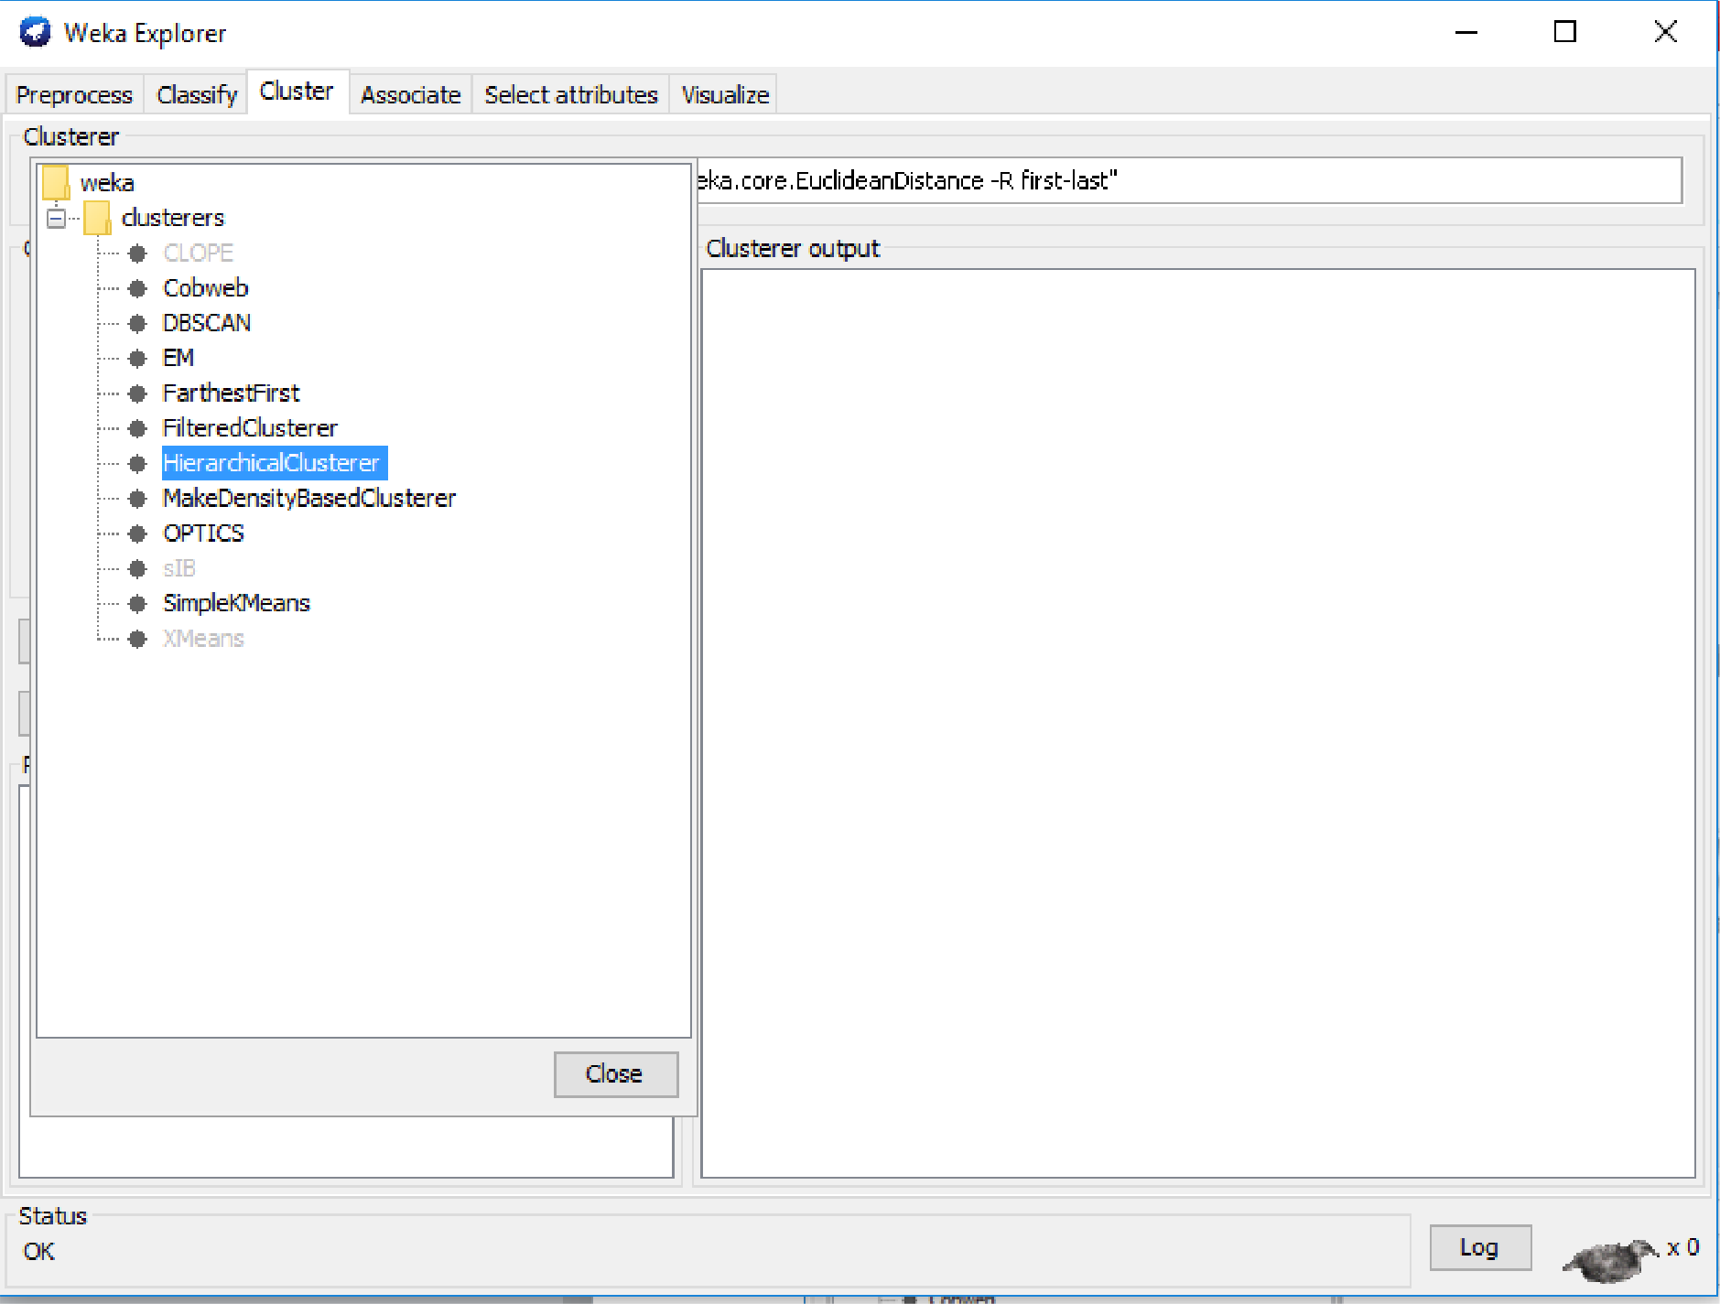

O Weka Explorer

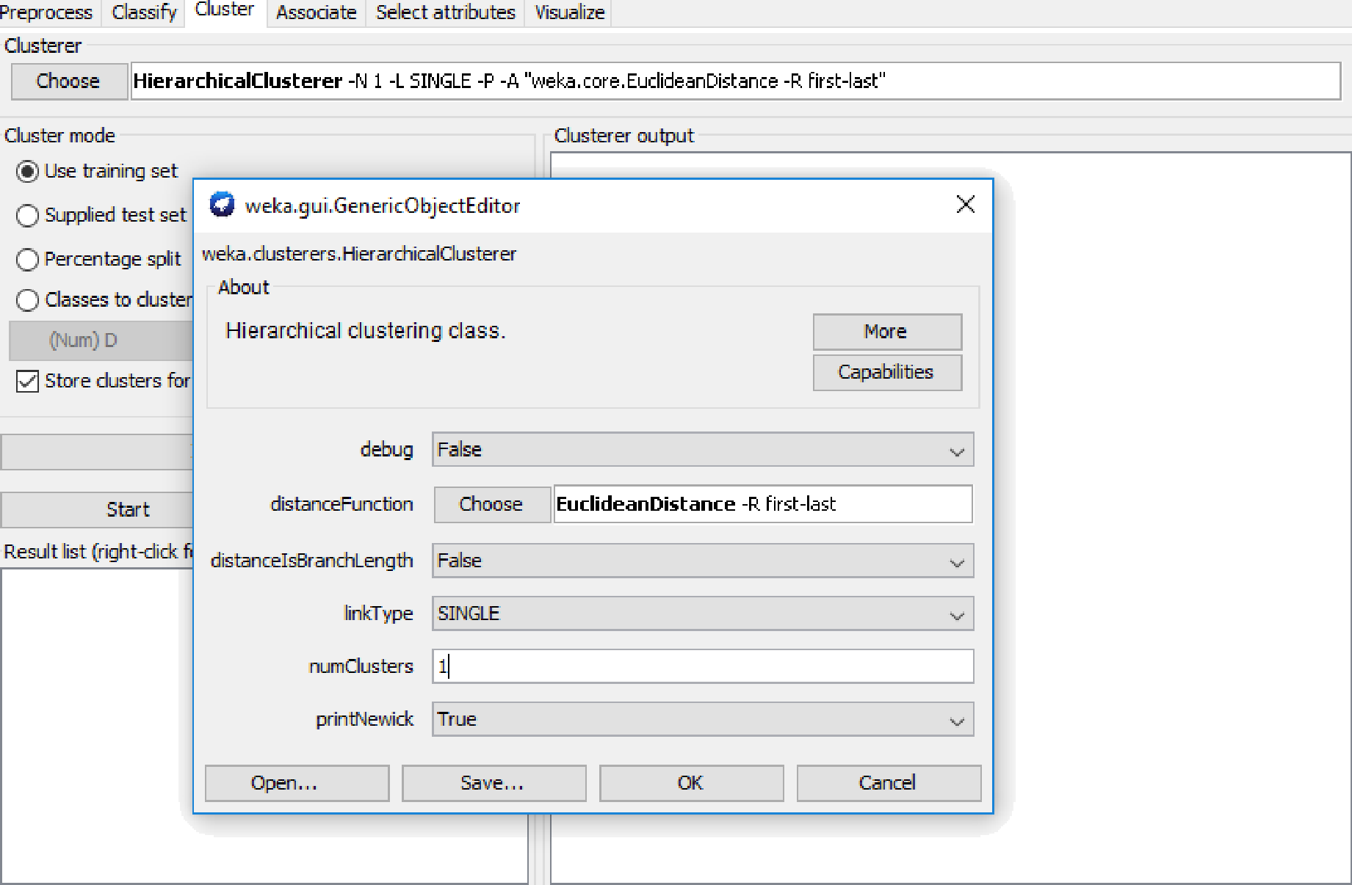


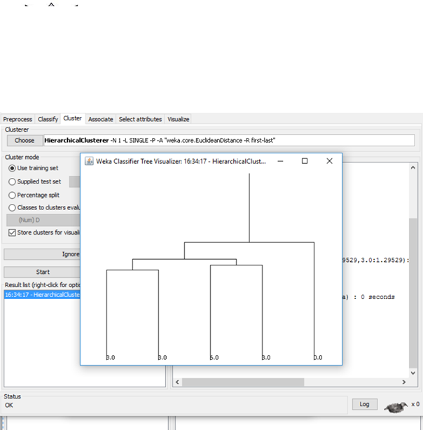

Conclusion:

